[](https://www.google.com/imgres?imgurl=https%3A%2F%2Fvajiramandravi.s3.us-east-1.amazonaws.com%2Fmedia%2F2019%2F3%2F30%2F13%2F9%2F24%2Fdefault-facebook-thumb.jpg&imgrefurl=https%3A%2F%2Fvajiramias.com%2Fcurrent-affairs%2Fred-cross-ifrc%2F5c9f1d6f1d5def084fe25d91%2F&docid=v6WQKlO4UvwvyM&tbnid=JXWuzbSMPX8DSM%3A&vet=10ahUKEwiYzoGWq5jkAhUOzKQKHUHRBlMQMwiHASgfMB8..i&w=980&h=514&bih=655&biw=1366&q=ifrc%20logo&ved=0ahUKEwiYzoGWq5jkAhUOzKQKHUHRBlMQMwiHASgfMB8&iact=mrc&uact=8) **Communal latrine Construction KEY MESSAGES**

For a site with 20 households, with approximately 100 persons, we propose 2 blocks of 4 toilets (separate men’s and women’s)

1. **Selecting latrine location**

* Stay 30 m away from water supply area to prevent contamination from leaching or flooding
* Locate near homes to assure security, provide lighting for night use
* Avoid obvious rocky area, dig small test hole
* Plan for separate men’s and women’s latrine blocks, each 2 x 5 of level ground
* Consider easy access to a water storage site to ensure washing supply

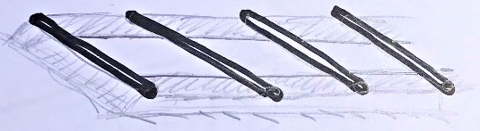

**←30 cm→←30 cm→**

1. **Excavating the pit**

* For a 4-latrine block, dig a 4 x 1 m hole, at least 2 meters deep (should be 1.5 m above water table)
* A lining of stone to protect to top edges from erosion, if loose soil, protect entire pit wall
* Raise the top 20 cm above grade with compacted soil to protect from surface water and vermin (one step)

1. 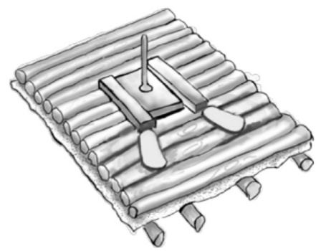**a. Wood slab**

* Start with 14 strong support beams treated with motor oil, 160 cm
* Rest beams firmly on the edges of the pit, treated with motor oil
* Covers with plastic or other woven material, leave a hole for the venting pipe
* Closely spaced wood floor, with a hole in the middle
* Cover with compacted layer of soil to allow cleaning (after walls are built)

**b. Concrete slab (easier to clean)**

* For non-reinforced slab, use same frame as above, with liner
* Pour a 6 cm slab, using clean sand and cement, 1:4 ration, leave a hole for venting pipe

**For all**

* 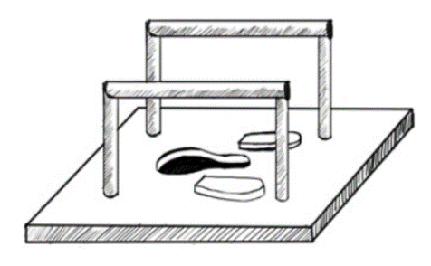Provide handrails for the elderly or persons with disabilities
* Make a cover for the hole to stop insects and vermin form entering
* Provide a hole in the slab for a venting pipe

**4. Structure**

* Posts should be 30 cm in the ground, protected with motor oil
* Use diagonal bracing to ensure strength
* Walls of chikka or woven material should provide privacy and security
* Door needs lock on inside and width large enough for persons with mobility challenges
* Roof can be local material or metal roofing, ensure some light inside
* Venting pipe should reach through the roof to outside, and be screened from insects

**5. Maintenance**

* Organize a share cleaning responsibility schedule and ensure easy water provision to the site
* Check for cracks in slab or damage to superstructure and repair mediately
* Once pit is filled to 75cm from top, transfer slab to new pit, cover and seal old pit
* Ensure personal protection and disinfection after working with contaminated materials