IFRC WASH Rapid Assessment Checklist for Disaster Response
This checklist aims to provide a comprehensive framework for RCRC WASH practitioners to assess and respond effectively to the WASH needs in the aftermath of a disaster.
How to use this checklist:
- Use the checklist as an aid to guide you on what information to collect.
- Use annexes 1 and 2 to create an assessment report.
- It is recommended that you convert Annex 2 to an Excel spreadsheet or Google Sheet.
- Use annex 3 for more detailed programme planning.
- Use annex 4 to create the WASH operational strategy.

1. Situation Overview
☐ Gather information on the scope and scale of the disaster.
☐ Identify and describe affected areas and populations (including population density).
☐ Assess the immediate impact on water, sanitation, and hygiene facilities and practices.
☐ Assess National Society capacity and ongoing response activities.
☐ Assess government and other response actors’ capacity and ongoing response activities.
2. Water Supply
☐ Determine the availability of drinking water sources.
☐ Assess the quality of available water and water storage (contamination risks).
☐ Identify any damages to water supply infrastructure or risks associated with water handing.
☐ Identify any ongoing household water treatment or storage practices and indicate whether HWTS materials are available locally.
☐ Evaluate the need for water trucking or temporary water storage solutions.
☐ Estimate the population's water needs (liters/person/day).
3. Sanitation
☐ Assess the status of excreta disposal facilities (toilets, latrines, sewage systems).
☐ Identify areas (if any) where open defecation is occurring due to lack of facilities.
☐ Determine the need for emergency sanitation solutions (portable toilets, pit latrines, desludging, rehabilitation of infrastructure), including services for children and people with disabilities.
☐ Evaluate solid waste management systems.
4. Hygiene
☐ Evaluate current hygiene practices (including menstrual hygiene) in the affected areas.
☐ Evaluate handwashing/bathing practices and facilities and whether they are they used
☐ Identify the need for hygiene promotion activities.
☐ Assess and identify gaps in the availability of hygiene supplies (soap, disinfectants, menstrual hygiene products).
☐ Evaluate the feasibility of cash and voucher assistance for hygiene items
5. Health and Vulnerable Populations
☐ Identify any outbreak of water related diseases (e.g. cholera, malaria).
☐ Assess the health status of the affected population, focusing on vulnerable groups (children, elderly, pregnant women).
☐ Determine access to health facilities, availability of health services and WASH services at health facilities.
6. Coordination and Collaboration
☐ Identify key stakeholders and partners (local authorities, NGOs, UN agencies).
☐ Establish communication lines with relevant WASH sector actors and attend coordination meetings.
☐ Coordinate with other sectors (health, shelter, food security) to ensure a holistic response.

Annex 1: WASH Narrative Assessment Report
1. Situation Overview
(Information on the scope and scale of the disaster, affected areas and populations (including population density) and overview of the immediate impact on water, sanitation, and hygiene facilities and practices. Details of National Society, government and other response actors’ capacity and ongoing response activities.)

2. Water Supply
(Overview of the availability of drinking water sources., quality of available water and water storage, damages to water supply infrastructure, water handling issues, HWTS practices and availability and population's water needs in the affected areas.)

3. Sanitation
(Overview of the status of excreta disposal facilities, open defecation practices (if any), solid waste management and need for emergency sanitation solutions in the affected areas)

4. Hygiene
(Overview of current hygiene practices (including menstrual hygiene), need for hygiene promotion activities, gaps in the availability of hygiene supplies (soap, disinfectants, menstrual hygiene products) feasibility of cash and voucher assistance for hygiene items in the affected areas.)
5. Health and Vulnerable Populations
(Overview of incidence or outbreak of water related diseases, health status of the affected population (focusing on vulnerable groups), access to health facilities, availability of health services and WASH services at health facilities).
6. Coordination and Collaboration
(Overview of key stakeholders and partners, communication channels established with relevant WASH sector actors and coordination meetings. Outline ongoing coordinate with other sectors (health, shelter, food security) to ensure a holistic response.)

Annex 2: Quantitative WASH Assessment Report
It is recommended that you create an Excel spreadsheet or Google sheet for this information

Indicator | Value
# of people affected by emergency
target population for response
% of target population that has access to sufficient safe water
estimate of population's water needs (liters/person/day).
% of target population that is using adequate sanitation
estimate of number of people per toilet
% of target population carrying out good hygiene practices
# of site assessments carried out and shared
family size used for planning purposes
#number of RCRC volunteers available for WASH assessment and response activities

Annex 3: Steps for more detailed, longer term programme planning

1. Community Engagement and Participation
☐ Engage with community leaders and members to identify their needs and priorities.
☐ Involve the community in planning and implementing WASH interventions.
☐ Ensure the inclusion of marginalized and vulnerable groups.
2. Capacity Building and Training
☐ Assess the capacity of local WASH committees and RCRC volunteers.
☐ Provide training on WASH assessment and WASH activities.
☐ Strengthen local capacities for operation and maintenance of WASH facilities.
3. Implementation Plan
☐ Develop a detailed WASH response plan based on the assessment findings and using the template in annex 4.
☐ Identify and request/procure necessary human resources, WASH response tools (e.g. ERUs), local contractor services, materials and equipment.
☐ Set timelines and assign responsibilities for each activity.
4. Monitoring and Evaluation
☐ Establish monitoring indicators for water supply, sanitation, and hygiene activities.
☐ Design and conduct baseline survey to establish current WASH coverage and practices.
☐ Conduct regular site visits to assess progress and address challenges.
☐ Collect feedback from the affected population and adjust interventions accordingly.
5. Reporting
☐ Prepare regular reports on the status of WASH activities and outcomes.
☐ Share reports with relevant stakeholders and partners, including technical line management in Regional office and HQ.
☐ Create a decision log for future WASH focal points.
☐ Document lessons learned and best practices for future responses.
6. Handover
☐ Develop a handover plan to transfer responsibilities for future WASH focal points and or NS.

Annex 4: Operational Strategy Template

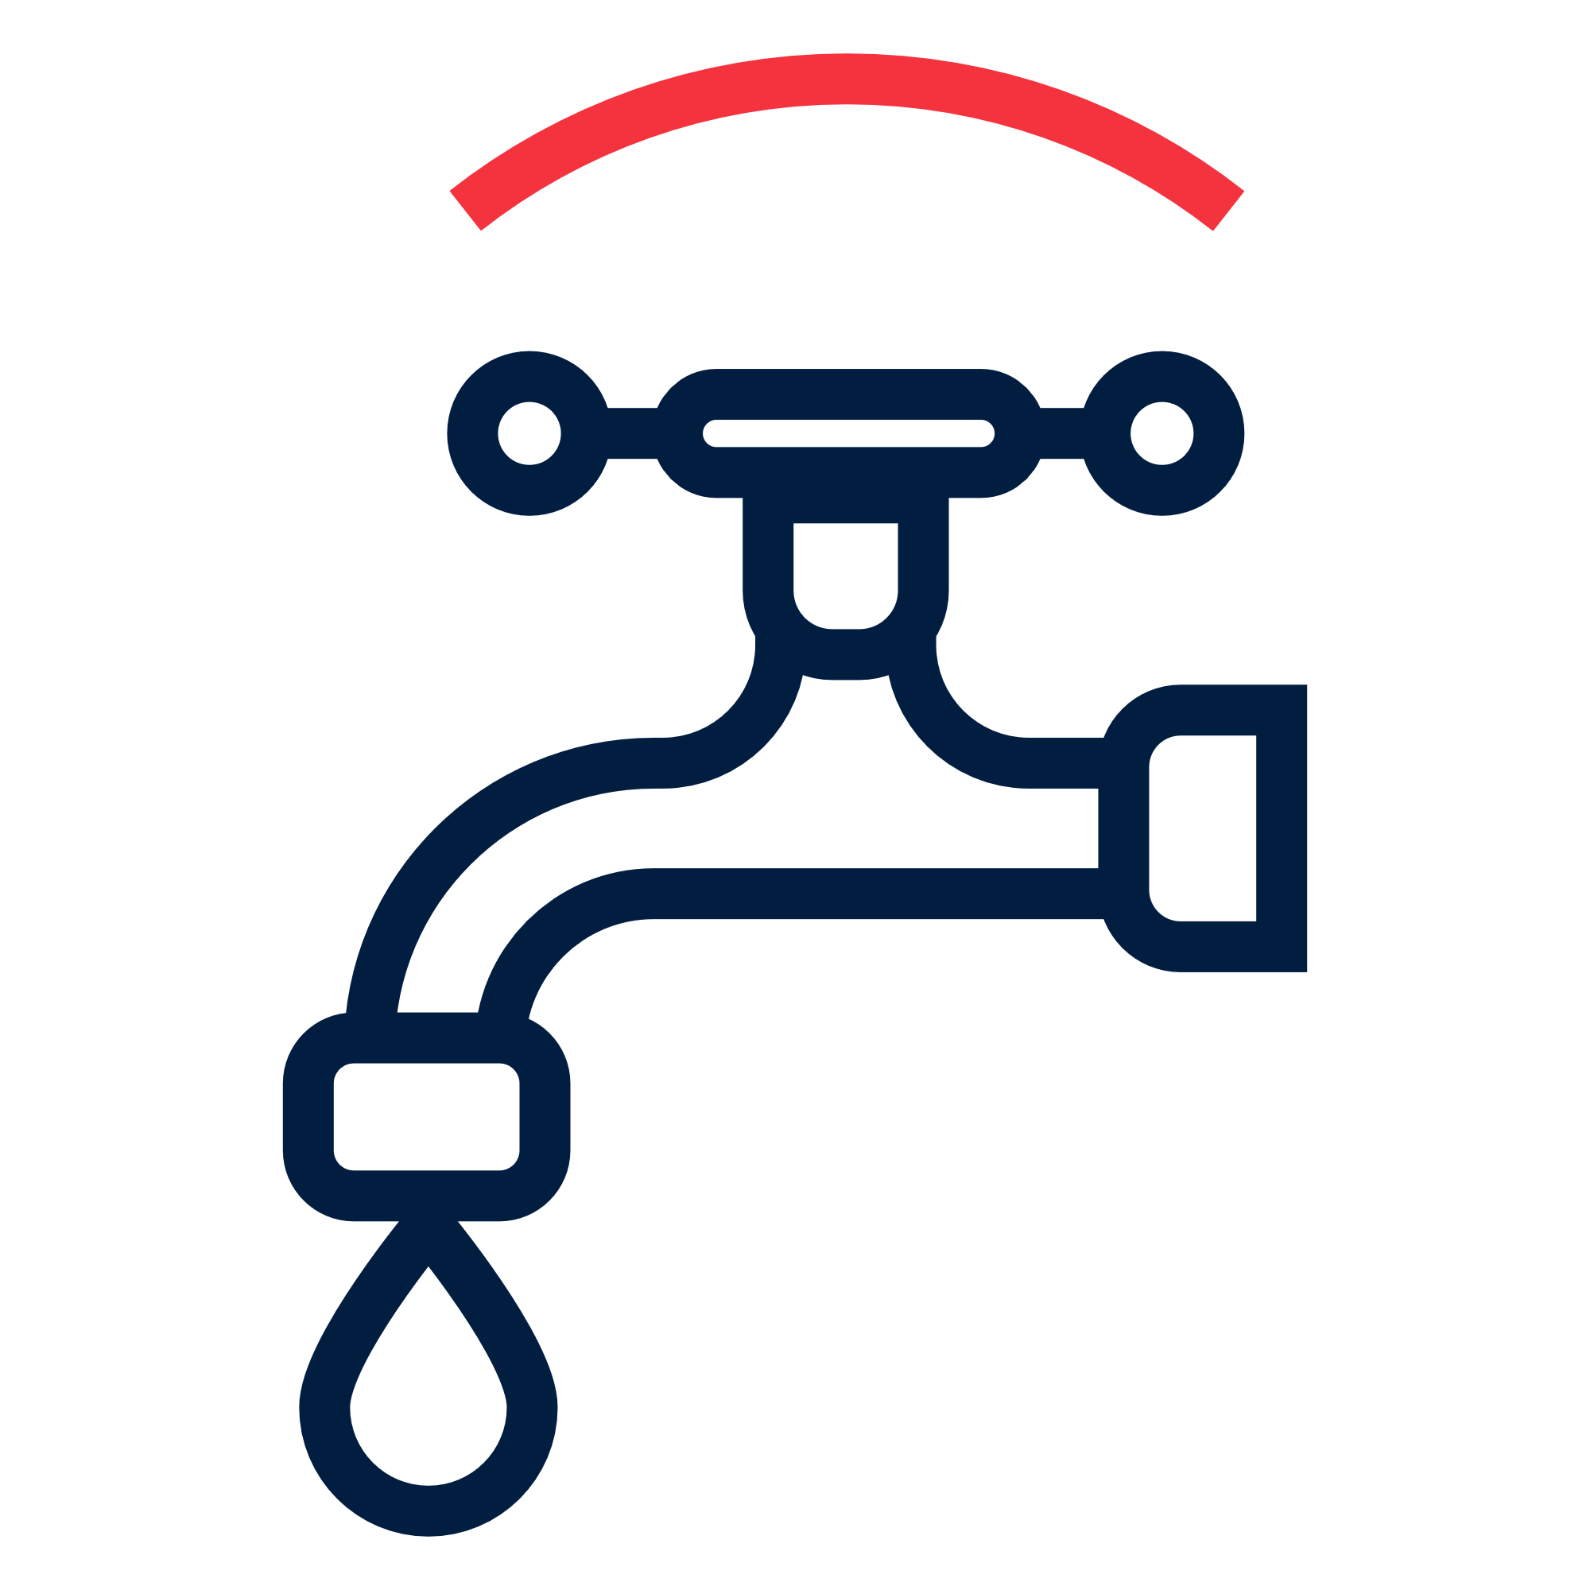 | Water, Sanitation and Hygiene | Female > 18: XXXX | Female < 18: XXXX | XXXXX CHF
 |  | Male > 18: XXXX | Male < 18: XXXX | Total target:
Objective: Immediate reduction in risk of waterborne and water related diseases in targeted communities |  | Refer to technical guidance
Priority Actions: |  | - Conduct training for RC volunteers on carrying out water, sanitation and hygiene assessments  - Coordinate with other WASH actors on target group needs and appropriate response.  - Provide safe water to XX people in targeted communities through [SPECIFY SOURCE OF WATER: e.g. water trucking, well or pipeline rehabilitation, mobile water treatment plant, or household water treatment].-If household water treatment: Distribute XX household water treatment products [SPECIFY: chlorine tablets, sachets, liquid chlorine, or filters], sufficient for XX days, to XX people.  - Train population of targeted communities (SPECIFY: on safe water storage, on safe use of water treatment products, hygiene NFIs)  - Construct XX toilets in XX [SPECIFY LOCATION: households, schools, health centres, public areas] for XX people.  - Carry out [SPECIFY ENVIRONMENTAL SANITATION ACTIVITIES: drainage, vector control, and solid waste] in targeted communities.  -or-  Mobilize targeted communities to construct XX toilets and carry out environmental sanitation activities.  - Carry out hygiene promotion activities based on IFRC Hygiene Promotion in Emergencies Guideline in targeted communities  - Distribute XX hygiene kits or cash and voucher assistance for hygiene items, sufficient for XX month(s) to XX people.  - Monitor use of hygiene kits and water treatment products and user’s satisfaction through household surveys and household water quality tests.

