IFRC WASH TRAINING EXERCISE
Exercise: spot the problems with a rainwater harvesting installation
Module 2, Topic 10: Roof catchment systems for rainwater harvesting (RWH) · Handout 2 (exercise) · Curriculum pp. 68–69
Trainees look at the drawing of a rainwater harvesting installation that is not working well and try to identify the problems and suggest solutions.
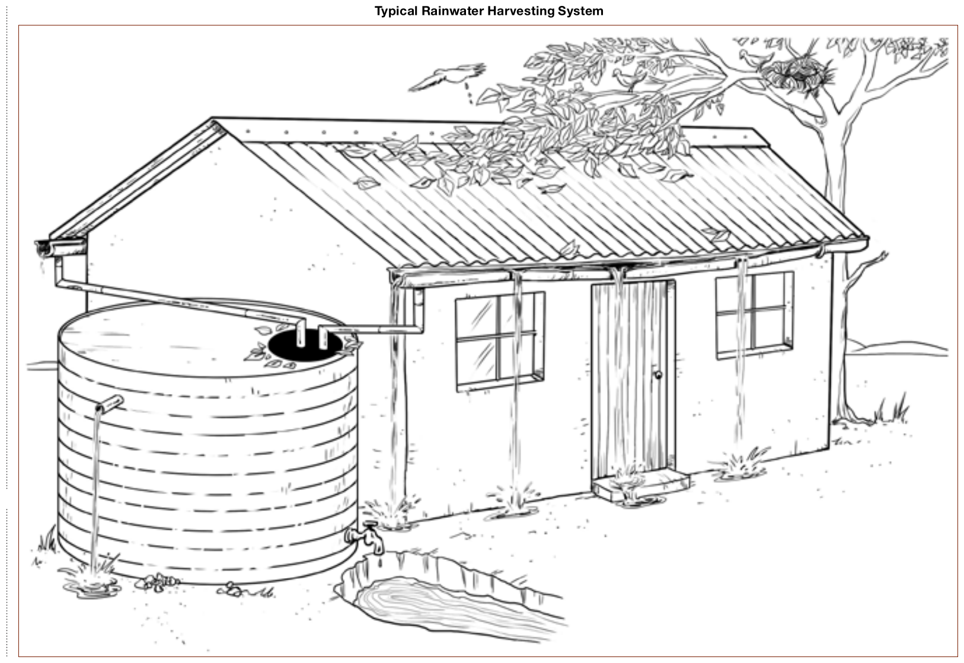

Answer key for the facilitator
The Problems
1. The gutter brackets are too far apart and the gutter has sagged so that water is spilling out. 2. One of the gutter joints is leaking. 3. The rainwater tank is overflowing, which suggests that it may be not big enough to capture all the water from both sides of the roof. 4. The overflow from the rainwater tank is too low so the tank can never fill completely. 5. The outlet for drawing water from the tank is too high so all the water cannot be used. 6. The tank is sitting on the ground so to get a bucket under the outlet, a hole has been dug. This becomes wet and muddy because of spillage. 7. The top of the tank has no cover to prevent rats, lizards etc. from falling in. 8. There is no mesh or gauze to prevent mosquitoes from entering the tank. 9. The trees over the house encourage birds to pollute the roof with droppings. 10. Leaves from the trees will block the gutters and downpipes. 11. The downpipe has a 90-degree bend which is liable to block with the leaves. 12. There is no mechanism to prevent rubbish from passing straight into the tank.
Suggested solutions
1. Put brackets closer together or use a stronger material for the gutter. 2. Repair leaks by soldering if the gutter is metal or use bitumen sealant. 3. Look for a second tank to take water from the other side of the roof. 4. Close the existing overflow pipe and put a new one nearer the top of the tank. 5. Select or construct tanks with the outlet near the bottom. 6. Raise the tank on a plinth above ground level and make a drain to carry away any water that spills from the outlet. 7. Use a cover that rats, lizards and other animals cannot pass through. 8. Use mosquito mesh or gauze over the openings to the tank. 9. Cut back the branches of the trees so they don’t overhang from the roof. 10. Clean the gutters before each rainy season. 11. If bends are needed in the downpipe, use ones at a 45-degree angle. 12. Check whether it is possible to install a 45-degree self-cleaning screen at the tank inlet.

