IFRC WASH TRAINING EXERCISE
Exercise: spot the problems with a sand dam
Module 2, Topic 6: Sand dams and subsurface dams · Attachment 1 · Curriculum pp. 48–49
Volunteers look at the drawing of a sand dam construction and try to identify any problems and suggest solutions.
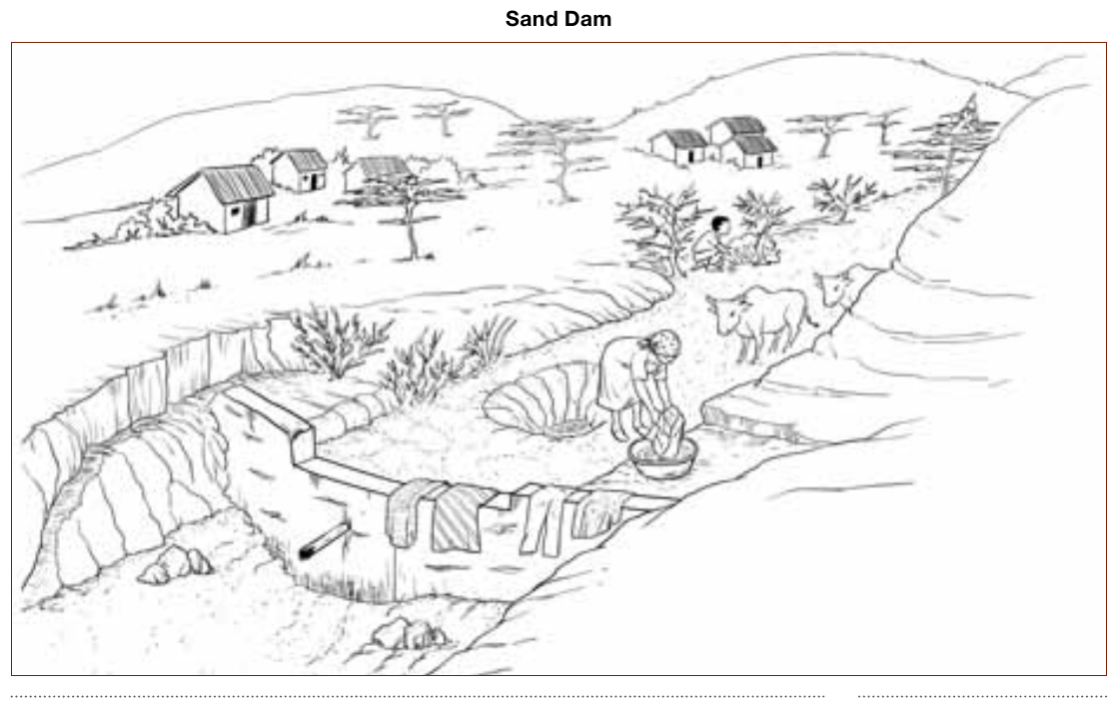
Problems
- The wing wall is missing or broken and flood waters are bypassing the dam. Eventually all the sand will be swept downstream and the dam will cease to function.
- The dam wall is being undercut by the waterfall during floods probably because the foundation was poorly constructed and there was no apron. If nothing is done it will collapse.
- The dam is not fenced so livestock can wander in freely.
- Weeds and bushes are growing on the dam and extracting water through transpiration.
- Livestock are polluting the water.
- A person is defecating on the riverbank.
- A woman is washing clothes and tipping the dirty water back onto the sand.
- The pipe has lost its tap and is spilling water that may be needed later.
- The hole dug in the sand is deep and dangerous, especially for children trying to collect water.
Suggested solutions
1. Install a wing wall on proper foundations to ensure the flood waters go over the centre of the dam.
2. Repair the foundations and install an apron to take the impact of the water.
3. Provide a fence or hedge to the dam with a gate to enable people to access the dam.
4. Remove weeds and bushes growing within the dam.
5. Install a trough for watering livestock downstream and pipe the water from the dam to the trough.
6. Develop community awareness and education to prevent the spread of diseases and construct a pit latrine on the bank above the water level.
7. Install a shallow well to the side of the dam and educate the community to use water from this well for watering vegetables or tree seedlings (not drinking).
8. Check local regulations and find out if the pipe inlet must be kept open for the benefit of downstream users. If this is not necessary, pipe the water to a tap stand with a gate valve in a lockable manhole.

