Operational Strategy Template

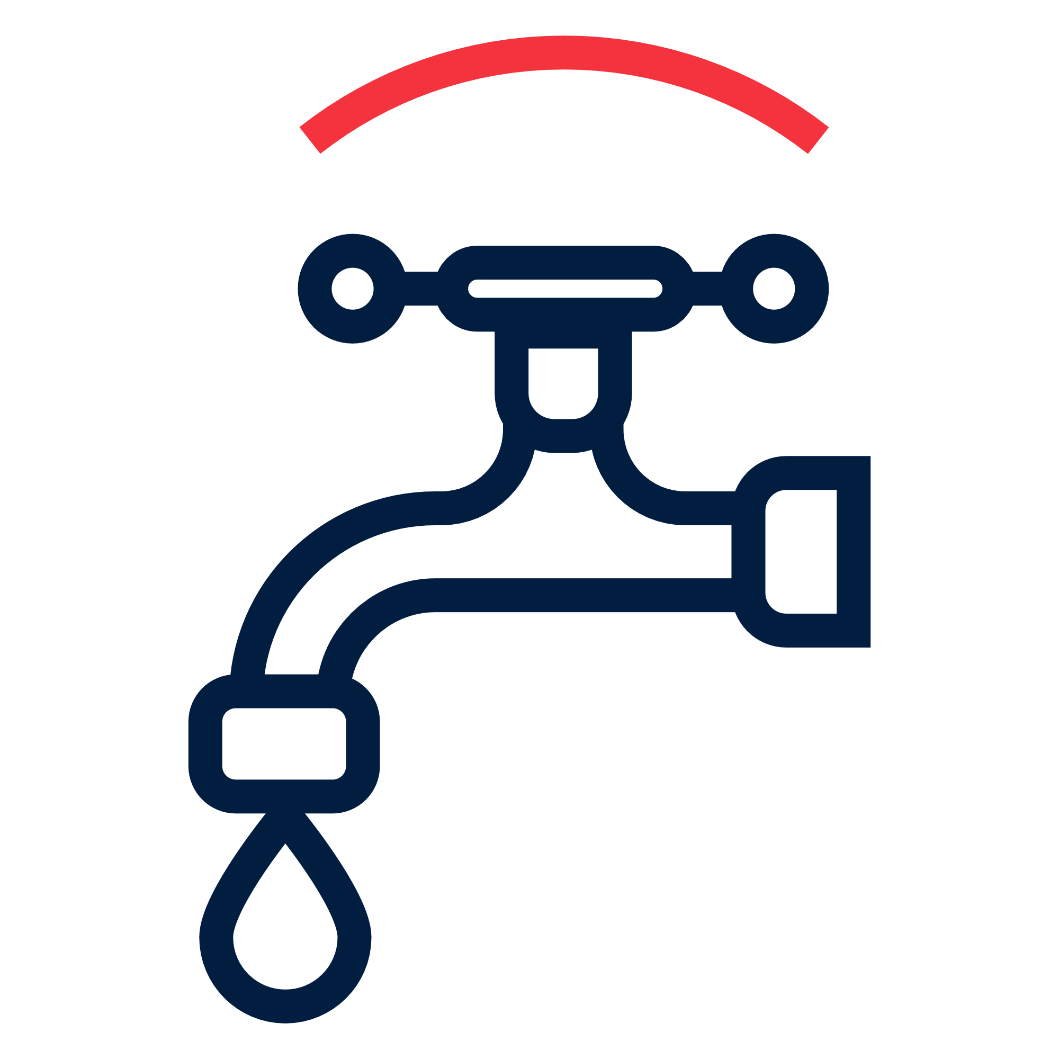 | Water, Sanitation and Hygiene | Female > 18: XXXX | Female < 18: XXXX | XXXXX CHF
 |  | Male > 18: XXXX | Male < 18: XXXX | Total target:
Objective: Immediate reduction in risk of waterborne and water related diseases in targeted communities |  | Refer to technical guidance
Priority Actions: |  | - Conduct training for RC volunteers on carrying out water, sanitation and hygiene assessments  - Coordinate with other WASH actors on target group needs and appropriate response.  - Provide safe water to XX people in targeted communities through [SPECIFY SOURCE OF WATER: e.g. water trucking, well or pipeline rehabilitation, mobile water treatment plant, or household water treatment].-If household water treatment: Distribute XX household water treatment products [SPECIFY: chlorine tablets, sachets, liquid chlorine, or filters], sufficient for XX days, to XX people.  - Train population of targeted communities (SPECIFY: on safe water storage, on safe use of water treatment products, hygiene NFIs)  - Construct XX toilets in XX [SPECIFY LOCATION: households, schools, health centres, public areas] for XX people.  - Carry out [SPECIFY ENVIRONMENTAL SANITATION ACTIVITIES: drainage, vector control, and solid waste] in targeted communities.  -or-  Mobilize targeted communities to construct XX toilets and carry out environmental sanitation activities.  - Carry out hygiene promotion activities based on IFRC Hygiene Promotion in Emergencies Guideline in targeted communities  - Distribute XX hygiene kits or cash and voucher assistance for hygiene items, sufficient for XX month(s) to XX people.  - Monitor use of hygiene kits and water treatment products and user’s satisfaction through household surveys and household water quality tests.

