Branch Outbreak Response Team
Rapid Assessment Tools

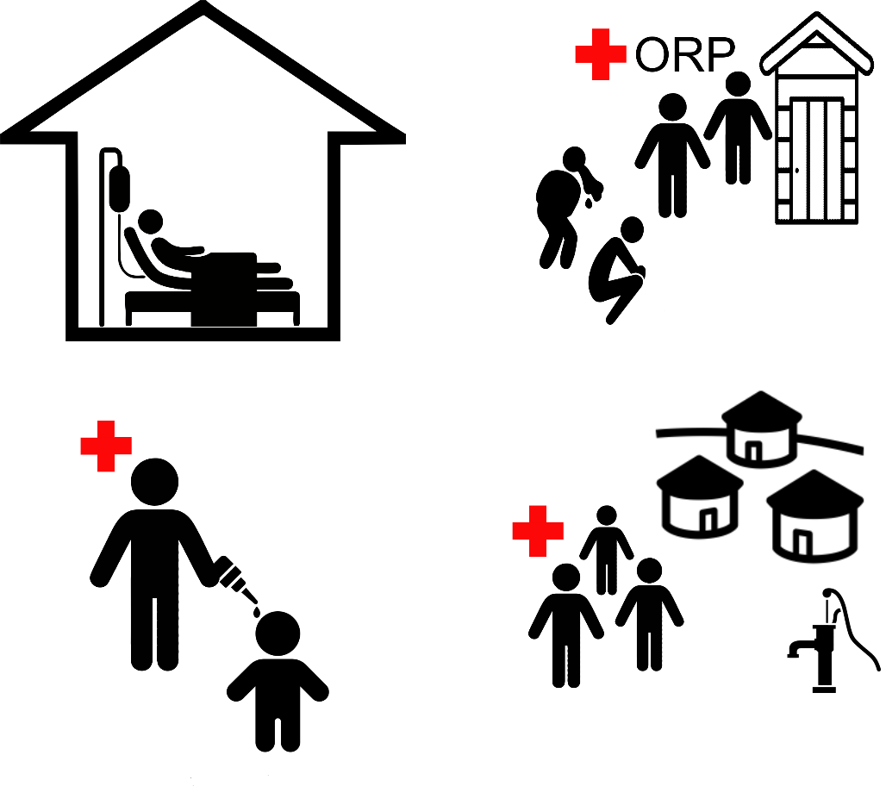

Version 2.1 8 March 2022

Guidance
The rapid risk assessment is a checklist that requires team members to observe in order to identify potential sources of contamination. During visits to they will assess risk and use the findings to break transmission in the home and between homes and in shared spaces.

Follow this approach:
- Act in order of greatest risk. For example, assume all water is contaminated as it was either a source for infection of the household case or else was contaminated by the household member or their carers.
- Instruct the household members on how to protect their family and watch as they act (treating water, cleaning contaminated materials, washing hands, disinfecting surfaces, etc). Raise awareness of how cholera is transmitted.
- Ensure proper protective clothing is used with concentrated chlorine.
- Encourage those with symptoms to attend ORP / cholera treatment center / pharmacy for ORT quickly before dehydration as deterioration happens rapidly.
- Do not leave out any steps.

A HEALTH FACILITY

1 Rapid risk assessment of cholera cases in health care facilities

Used by Team Leader or senior branch staff to understand origins of disease and so where to deploy the Team.

Doctor / nurse

WHEN?
What times were the patients
Date admitted Date became ill Disease

Patient 1: __ / __ / ____ __ / __ / ____ ¨ AWD/ suspected cholera ¨ confirmed cholera

Patient 2: __ / __ / ____ __ / __ / ____ ¨ AWD/ suspected cholera ¨ confirmed cholera

Patient 3: __ / __ / ____ __ / __ / ____ ¨ AWD/ suspected cholera ¨ confirmed cholera

Patient 4: __ / __ / ____ __ / __ / ____ ¨ AWD/ suspected cholera ¨ confirmed cholera

Patient 5: __ / __ / ____ __ / __ / ____ ¨ AWD/ suspected cholera ¨ confirmed cholera

Common exposures

Identify where two or more people’s behaviour was associated with same location:
Residence (where they lived in the past week)
Location: __________________________ (# people_____)
Events (e.g. wedding, festivals, celebrations, restaurants)
Location:___________________________ (# people____) Date: __/__/____

Conclusions on where to send team

Draw conclusions about common exposures:
- Mostly common location of residence – probably localized outbreak
- Mostly connected to special events/celebrations – localized to specific event in time and place
- Very different exposures – probably more disseminated outbreak that may require attending multiple locations.

Action:

Deploy team to most likely location(s): __________________________________

B HOUSEHOLD

Handwashing must be installed for use by the BORT members and household members. It is not included in any single section. However, the section on establishing a disinfection station gives guidance on the best location(s) for this. While there must be a handwashing station with sanitation, but remember that households often have no private latrine, and those who have people suffering cholera often have a potty / bucket for use by the very ill.

1 Cases of cholera
 | Direct observation for cases of cholera  (duty of care to the sick) | Yes | No | Protective action
Q1 | Any person with symptoms of diarrhoea / vomiting | è | ê | Refer to health facilities if severely ill or dehydrated, else ensure ORP or community volunteers provide them with ORS, clean water and guidance for carers.

2 Rapid risk assessment of household water
 | Direct observation for household water  Assume water is contaminated in a case household and in neighbours’ households | Yes | No | Protective action  
Q1 | Water storage containers are protected from contamination and kept clean.  Observations (notes for volunteers)  Observe that the container used for storage of drinking water are:  - kept in a separate container.  - kept above floor level and away from contamination.  - have a narrow mouth/opening and/or have a lid/cover.  - the volunteer can infer by observation from the status of the container if it is cleaned regularly, including inside and outside.  For next observation the volunteer can ask for drinking water and observe the behaviour.  - The utensil used to draw water from the water container are clean and kept away from surfaces and stored in a hygienic manner.  - When drawing drinking water, fingers or any part of the hand do not enter water. | ê | è | Clean and disinfect the water collection and storage containers regularly.  Avoid contact with hands.    Set up container with tap and demonstrate​ how to use it.  Keep water containers covered and above the ground level.  èQ2
Q2 | Is the drinking water clear?  - If cloudy then the water is turbid, needs filtering as pre-treatment if cloudy, dirty before chlorination. | ê | è |   Demonstrate filtering of the water using a cloth to reduce turbidity​. This step is important and need to be done before water treatment demonstration.  èQ3
Q3 | Residual chlorine in drinking water?  (As proxy check the presence of chlorine tablets or bleach for water treatment)  - Observe if chlorination materials are available for household water disinfection  - Check if community have access to these | ê | è | 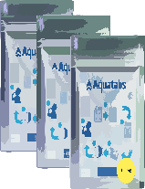  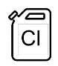  Treat existing HH water if not treated, demonstrating use of water chlorine treatment (i.e. sachets, tablets - or locally available treatment). (refer to slide 73 in module 5)  Leave behind 4 weeks supply depending on how soon community chlorination will begin. ​(Step-by-step instruction in the flipchart from the communication material)  èQ4
All HH should have information card taped to the wall where water is stored.
Community Link Question: (this will be investigated by team working in shared spaces)
Find out the location of the source(s) the household uses for water supply?
What type of source is it?
3 Establish disinfection area
 | Direct observation for household disinfection area | Yes | No | Protective action
Q1 | Is there a suitable location indoors where there is space to clean? Should be away from food and drinking water. | è | ê |   Establish disinfection area inside  Soap (for handwashing and body)  Jerry can, string, wood for tippy tap  10 liter bucket, cloths and disinfectant (chlorine)  Laundry soap    Info card: handwashing frequency.  Info card: parts of hand often missed.    Wash water is 0.2% chlorine solution. Use gloves. Stronger will damage cloth.  Establish drying area with washing line (whatever they normally use).
 | Find a sheltered area outside which allows cleaning and handwashing. Ensure there is no risk of contamination of water sources. |  |  | Establish disinfection area as above.  Establish drying area with washing line (whatever they normally use).
 | Locate handwashing conveniently where safe drainage allows to reduce contamination risk within household |  |  | Handwashing water to be 0.05% chlorine solution. Ensure safe drainage
Q2 | Is there a place for emptying 0.2% chlorinated wastewater which will not risk surface water or groundwater? – ideally a pit latrine | è | ê | Dispose of chlorinated water in latrine
 | Locate safe place for disposal of chlorinated water |  |  | Dispose of chlorinated water safely

4 Rapid risk assessment of household kitchen area
 | Direct observation for household kitchen / food preparation area  (As a proxy for food hygiene habits) | Yes | No | Protective action  
Q8 | Check that plates and utensils are off the ground. | ê | è | 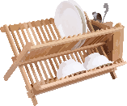  Demonstrate the safe storage and usage of plates and utensils (i.e. use of rack etc...)  èQ9
Q9 | Check that food is covered and protected from flies all the time. | ê | è | 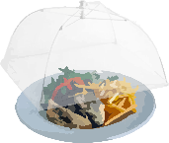  Demonstrate the use of the food cover.  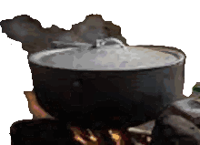  Remind to cook food well (especially seafood) and eat it hot.  èQ10
Q10 | Are all kitchen food preparation surfaces cleaned with disinfection solution. | ê | è |   Demonstrate the use of disinfectant for cleaning all kitchen surfaces (remind the right concentration of 0.2% chlorine for disinfection).  èQ11
Q11 | Is there a place for handwashing? | ê | è |   Construct tippy-tap and demonstrate its use (remind about soap and water always close to the handwashing unit)  èQ12
Q12 | Is water used to prepare uncooked food or drinks. | ê | è | 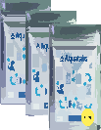  Ensure water used to prepare food is treated (see Household Water section above)  èQ13
Community Link Question: (this will be investigated by team working in shared spaces)
Find out the locations of places where the case and other members of the household eat when not at home.
5 Rapid risk assessment of household cholera case area
 | Direct observation for household cholera case area | No | Yes | Protective action  
Q13 | Check presence of detergent / cleaning product in the household. | ê | è | Demonstrate the use of disinfectant for cleaning all household surfaces (remind about the concentration of 0.2% chlorine for surface disinfection)  èQ14
Q14 | Check presence of any soiled laundry. | ê | è | Remove and wash using water and disinfectant of any soiled bedding or clothing by a person with acute watery diarrhea or cholera to avoid intra-household contamination. Wastewater must be chlorinated before disposal in latrine.  Remind use of plastic gloves.  èQ15
Q15 | Check presence of vomit or faeces. | ê | è | 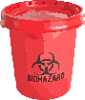  If currently caring, proper treatment and disposal of vomit and faeces (see above actions)
Q16 | Check status of household member(s) with AWD/cholera. | ê | è | Encourage to go to ORP or pharmacy to receive ORS - Oral Rehydration Salt) and cholera treatment center- CTC quickly if more severe to prevent dehydration - deterioration happens rapidly.

6 Rapid risk assessment of household sanitation
 |  | Direct observation for household sanitation | Yes | No | Protective action  
Q4 |  | Check presence of a latrine in the HH.  - If there is no latrine then you need to ask where they go to the toilet? are practicing open defecation? | ê | è | Remind of safe excreta disposal and use of latrine.  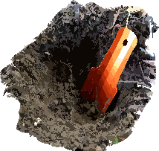  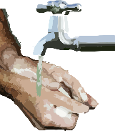  If practice open defecation (be sure to bury the faeces, do not defecate in any body of water and handwashing with soap and water after practice)  Collect and dispose properly children’s faeces.  èQ5
Q5 |  | Check if the latrine is clean.  - Presence of water container beside the latrines (for cleaning and flushing)  - Presence of lid to cover the latrine’ hole.  - Cleaning/disinfectant material are present nearby the latrine. | ê | è | Disinfect and clean the latrine regularly and the squatting pans are disinfected with a chlorine solution by way of demonstration. (remind about the concentration of 0.2% chlorine for surface disinfection)  Practicing good personal hygiene during process.  Ensure water stationed for cleaning and flushing.  Ensure the hole of the pit latrine is covered by a lid when is not use, if not promote to make a lid from plastic or wood and to cover the hole all the times.  èQ6
Q6 |  | Check for presence of a handwashing device nearby the latrines. | ê | è | Construct tippy-tap and demonstrate its use (remind about soap and water always present beside the handwashing unit). Consider safe drainage, and use 0.05% chlorinated water solution.  Practical demonstration of correct handwashing practice. ​(Steps by steps instruction in the flipchart from the communication material)  èQ7
Q7 |  | Availability of water / soap at the handwashing location and sign of use. | ê | è | Soap is provided in the kit; demonstrate options on its economic use e.g. Shavings or waste pieces dissolved in water/or collected in a net èQ8
Community Link Questions and observations: (this will be investigated by team working in shared spaces)
For facilities which the case and other members of the case household share with other households.
Find out the location of shared sanitation facilities (toilets).
Find the location of shared washing facilities (body, laundry).

C COMMUNITY SHARED SPACES

1 Rapid risk assessment of drinking water sources

Rapid risk assessment in community shared spaces. This is to identify potential risk of public water point contamination. Regardless of whether contamination is suspected or confirmed, water used for drinking should be treated as close to source as possible.
 | Direct observation for water sources | No | Yes | Protective action
1 | Is any surface water or unprotected ground source used for drinking? (this should be rare) | ê | è | 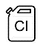    If ground sources exist, warn against use of unprotected water with signs and discussion. If no protected sources, establish single location for collection, establish chlorination system, chlorinate and test residual chlorineèQ2
2 | Is any protected ground water used for drinking? (shallow or tube well with pump?) | ê | è | 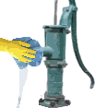  Disinfect pump mouth. Optional: take water sample for faecal coliform testing.  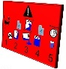  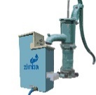  Chlorinate using passive dispenser (or active dispenser) and test residual chlorine. Adjust dispenser if necessary to ensure 0.5mg/l residual chlorine (affix signs).  èQ3
3 | Contact between hands and/or container and the well pump mouth – high risk for onward contamination | ê | è | 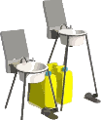  Signs and markers to prevent contact. Provide handwashing unit for water point and ensure it is routine (affix signs).  èQ4
4 | Cleaning of container and sharing of water between containers of others – high risk for onward contamination (more likely to occur with wide-mouthed containers) | ê | è | 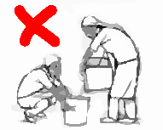  Signs and guidance to discourage sharing of water between containers of other households èQ5
5 | Is there an unsealed pit latrine within 30 meters of any surface/ground water sources? (can be less if soil permeability is known to allow closer proximity) | ê | è | 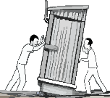  May potentially contaminate water source. Close latrine. Decommission in near future if possible.
6 | Is there laundry which is washed in rivers or near groundwater sources? | ê | è | 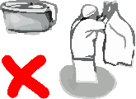  May potentially contaminate water source especially if from active cases. Discourage use. It is essential to prevent any case households from washing where others bathe or extract water for drinking.

2 Rapid risk assessment of water vendors
 | Direct observation for water vendors | No | Yes | 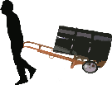  Protective action
1 | Is water source different to other sources being treated by the Team? | ê | è | Chlorinate at source as in previous assessment or drinking water sources.èQ2
2 | Is water stored and transported by vendors? | ê | è | 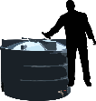  Any stored water should be chlorinated as it poses risk for multiple users. A system of regular chlorination must be established – vendor to hold chlorine in a safe place (away from children) and be instructed on dosing. èQ3
3 | Does vendor have access to handwashing? | ê | è | Encourage handwashing for vendor(s) and ensure it is routine. Direct them to units installed in community shared spaces èQ4
4 | Is water trucked from outside community? | ê | è | 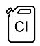  Trucks are unlikely to use chlorine on transport due to its ability to accelerate corrosion so you should chlorinate where stored.

3 Rapid risk assessment of food vendors (In restaurants and markets)
 | Direct observation for food vendors | No | Yes |   Protective action
1 | Is food uncovered risking contact with flies and other vectors? | ê | è | Encourage to use mosquito netting or inverted bowls on plates èQ2
2 | Are food preparation surfaces and utensils dirty, lacking evidence of cleaning? | ê | è | Encourage disinfection of surfaces and utensilsèQ3
3 | Do drinks/ice use unchlorinated water | ê | è | 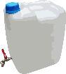  Drinks/ice should be chlorinated, or if not possible, destroyed and source water chlorinated. èQ4
4 | Are foodstuffs served cold or warm or stored for a period of time? | ê | è | Explain food should be thoroughly cooked until hot, especially shellfish (boiled 10 min), and not to store at room temperature for long periods. èQ5
5 | Is handwashing practiced by food servers? | ê | è | Provide handwashing unit for vendor(s) and customers and ensure it is routine (affix signs).èQ6
6 | Do people put plates and utensils on the ground? (not a risk for cholera, but for other infections) | ê | è | Discourage this and find a location somewhere clean

Remember, even if food was a common vehicle, if water is unchlorinated cholera will soon affect stored water

